To the Members of the EP

European Parliament

43 rue Wiertz

B- 1047 Brussels

Brussels, 6 December 2010

JD/WK/WW.HB

Re: **Single permit**: **No to the fragmentation of the labour market**

Dear Members of the European Parliament,

The vote on the proposal of a Directive on the single (work) permit will take place during the plenary of 13-16 December.  This proposal is unacceptable since there is no guarantee of equality of treatment for all workers.

Our key demand regarding the legislative proposal is equal treatment:

* 1.for seasonal workers
* 2.for workers subject to an intra-group posting
* 3.for posted workers from third countries
* 4.for workers entering by the GATS mode 4

With 23 million people unemployed and a growing number working under atypical, precarious and poor contracts, the creation of even more second- and third-category workers is worrying to say the least. With the extreme fragmentation of the labour market, we are also at risk of increasing xenophobia and racism, as well as industrial unrest.

The ETUC has repeatedly drawn MEPs’ attention (within the parliamentary committees and in messages to the presidents of the political groups) to the danger of adopting legislation on the single permit as proposed by the Commission.

The ETUC is convinced that these violations of the principle of equality of treatment run counter to the Charter on Fundamental Rights.

We therefore urge you to make sure that the draft single permit directive includes equality of treatment for all workers.

Thank you for considering this letter. We count on your support.

Kindest regards,

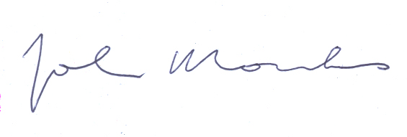



John Monks Joël Decaillon

General Secretary Deputy General Secretary

John Monks, General Secretary

Boulevard du Roi Albert II, 5 • B – 1210 Bruxelles • Tel: +32 2 224 04 11

Fax: +32 2 224 04 54 / 55 • e-mail: [etuc@etuc.org](mailto:etuc@etuc.org) • www.etuc.org